# **Shell Scripting**

You have been learning about Linux for some time, and it is time to start getting a feel of how to automate some work using Shell Scripts.

In this project, you need to onboard 20 new Linux users onto a server. Create a shell script that reads a csv file that contains the first name of the users to be onboarded.

Vi names.csv

Lawrence

Lord

Leslie

Philemon

Phillys

Philip

Kofi

Belinda

Yaa

Alice

Justice

Eric

Ethel

James

Paul

Ruth

Alain

Craig

Lily

Chris

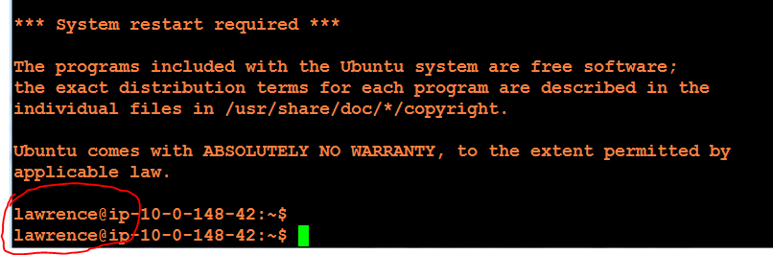

User Lawrence was able to login the ubuntu server successfully, with his own name.

This is how i completed this project.

1. I saved the keypair from my ubuntu instance and generated the public key and saved the private key on my CP and the public key on a notepad.
2. With $sudo su command I changed to UBUNTU home and having the Root privilege, I created a user.
3. $adduser lawrence and $id lawrence to verify.
4. I then switched to the new user’s account with the command $su - lawrence and $pwd to verify
5. Every key they use is stored in the .ssh authentication file, not a directory.
6. At lawrence home directory i $mkdir .ssh and $ls -a to verify
7. I then $cd .ssh and $vi authentication_keys and added the the new user (lawrence) public key and save and exit
8. I exit the system and able to login as the new user (Lawrence) on my next system login attempt.

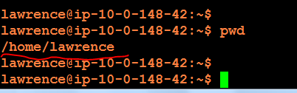

I tested users randomly, and ensured that they are able to connect to the server using their own private keys.